School Name
Mathematics Test 2017
Year 7 |  | Metric System | Non Calculator  Section
Skills and Knowledge Assessed:  - Connect decimal representations to the metric system (ACMMG135)  - Convert between common metric units of length, mass and capacity (ACMMG136)  - Solve problems involving the comparison of lengths and areas using appropriate units (ACMMG137)  - Connect volume and capacity and their units of measurement (ACMMG138)  - Solve problems involving duration, including using 12-and 24-hour time within a single time zone (ACMMG199)  - Interpret and use timetables (ACMMG139) |  |  | Name___________________
Answer all questions in the spaces provided on this test paper by:
Writing the answer in the box provided.
or
Shading in the bubble for the correct answer from the four choices provided.
Show any working out on the test paper. Calculators are not allowed.

Which would be a reasonable estimate for the mass of a kitten?

4 grams 40 grams
400 grams 40 kilograms

Julia takes 300 seconds to prepare a sandwich.
How many minutes does she take?
3 5
6 10
 | Use a ruler to measure the length of the line below, to the nearest mm.
There are 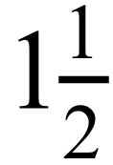 litres of milk left in a bottle.
How many millilitres is this?

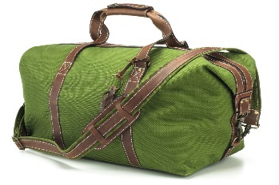
Emil has packed a bag, which weighs 6400 grams.
How many kilograms is this?

Which of the following is the same length as 320 centimetres?
32 mm 0.32 m 3.2 m 32 m

The Rudge family go to a movie which starts at 1:55 pm and finishes at 3:27.
How many minutes does the movie run?

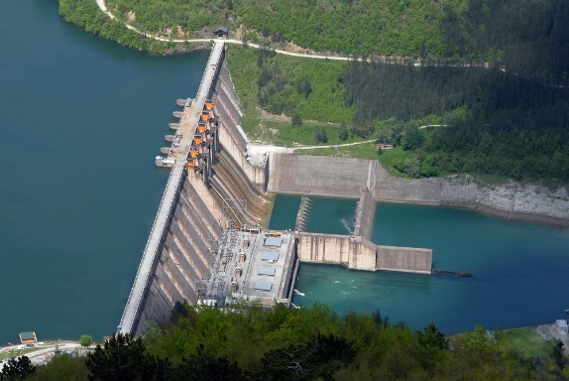
A water storage dam for a major city is full.
Which unit would be best to give its capacity?

Kilolitres
Litres
Megalitres
Millilitres
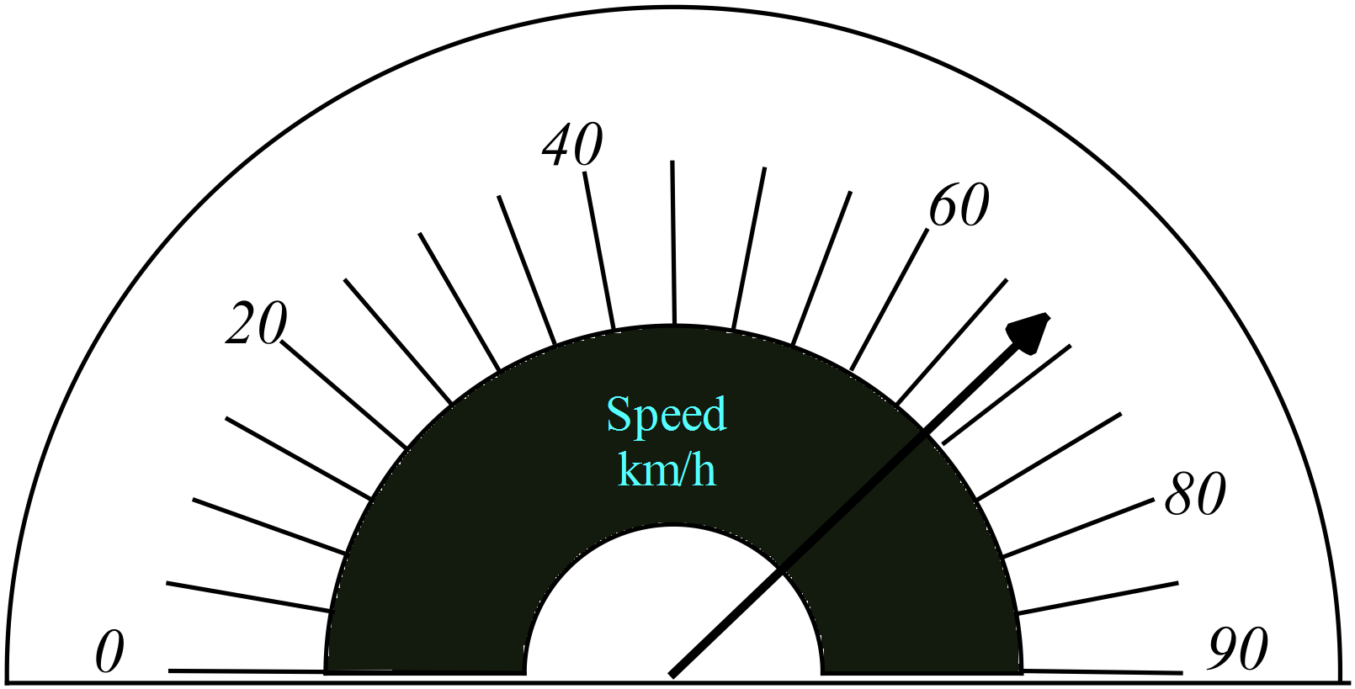What speed is shown on the scale below?

63 km/h 68 km/h 73 km/h 78 km/h
The length of Smith St was 6.75 km. Last year it was extended by 850 m.
What is the new length of Smith St (in km)?

Questions 11 – 13 refer to the train timetable below.

Central Station | 5:05 pm | 5:20 pm | 5:35 pm | 5:50 pm
Pitt St | 5:08 pm | 5:23 pm | 5:37 pm | 5:53 pm
Barangaroo | 5:11 pm | 5:26 pm | 5:40 pm | 5:56 pm
Victoria Cross | 5:15 pm | 5:30 pm | 5:44 pm | 6:00 pm
Crows Nest | 5:18 pm | 5:33 pm | 5:47 pm | 6:03 pm
Chatswood | 5:22 pm | 5:37 pm | 5:51 pm | 6:07 pm
North Ryde | 5:26 pm | 5:41 pm | 5:55 pm | 6:11 pm
Macquarie Park | 5:28 pm | 5:43 pm |  | 6:13 pm
University | 5:30 pm | 5:45 pm |  | 6:15 pm
Epping | 5:33 pm | 5:48 pm | 6:00 pm | 6:18 pm
Cherrybrook | 5:37 pm | 5:52 pm | 6:04 pm | 6:22 pm
Castle Hill | 5:41 pm | 5:56 pm | 6:08 pm | 6:26 pm
Showground | 5:44 pm | 5:59 pm |  | 6:29 pm
Norwest | 5:47 pm | 6:02 pm | 6:13 pm | 6:32 pm
Bella Vista | 5:49 pm | 6:04 pm | 6:15 pm | 6:34 pm
Kellyville | 5:51 pm | 6:06 pm | 6:17 pm | 6:36 pm
Rouse Hill | 5:54 pm | 6:09 pm | 6:20 pm | 6:39 pm
Cudgegong | 5:55 pm | 6:10 pm | 6:21 pm | 6:40 pm

Zevon catches a train at Victoria Cross at 5:30.
How many minutes does it take her to reach Rouse Hill?

What is the shortest time to get from Chatswood to Norwest??

20 minutes 22 minutes 25 minutes 27 minutes
Helen needs to be at Bella Vista by 6:25 to catch a connecting bus.
What is the latest time that she could catch a train from Crows Nest?

Matthew leaves home for school, in the morning, at the time shown on the clock on the left and arrives home at the time shown on the phone on the right.
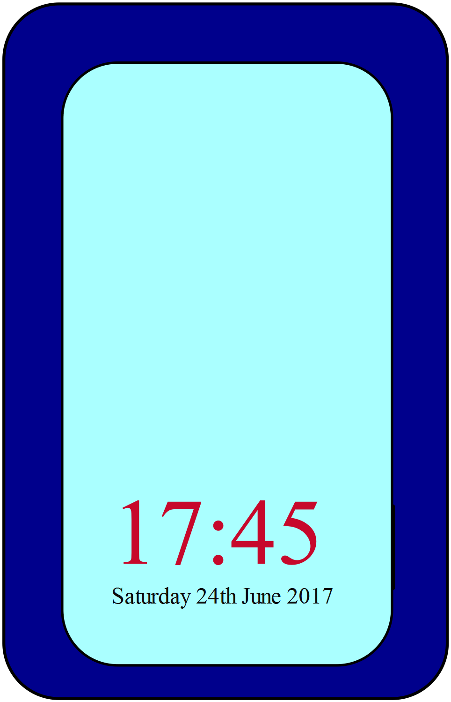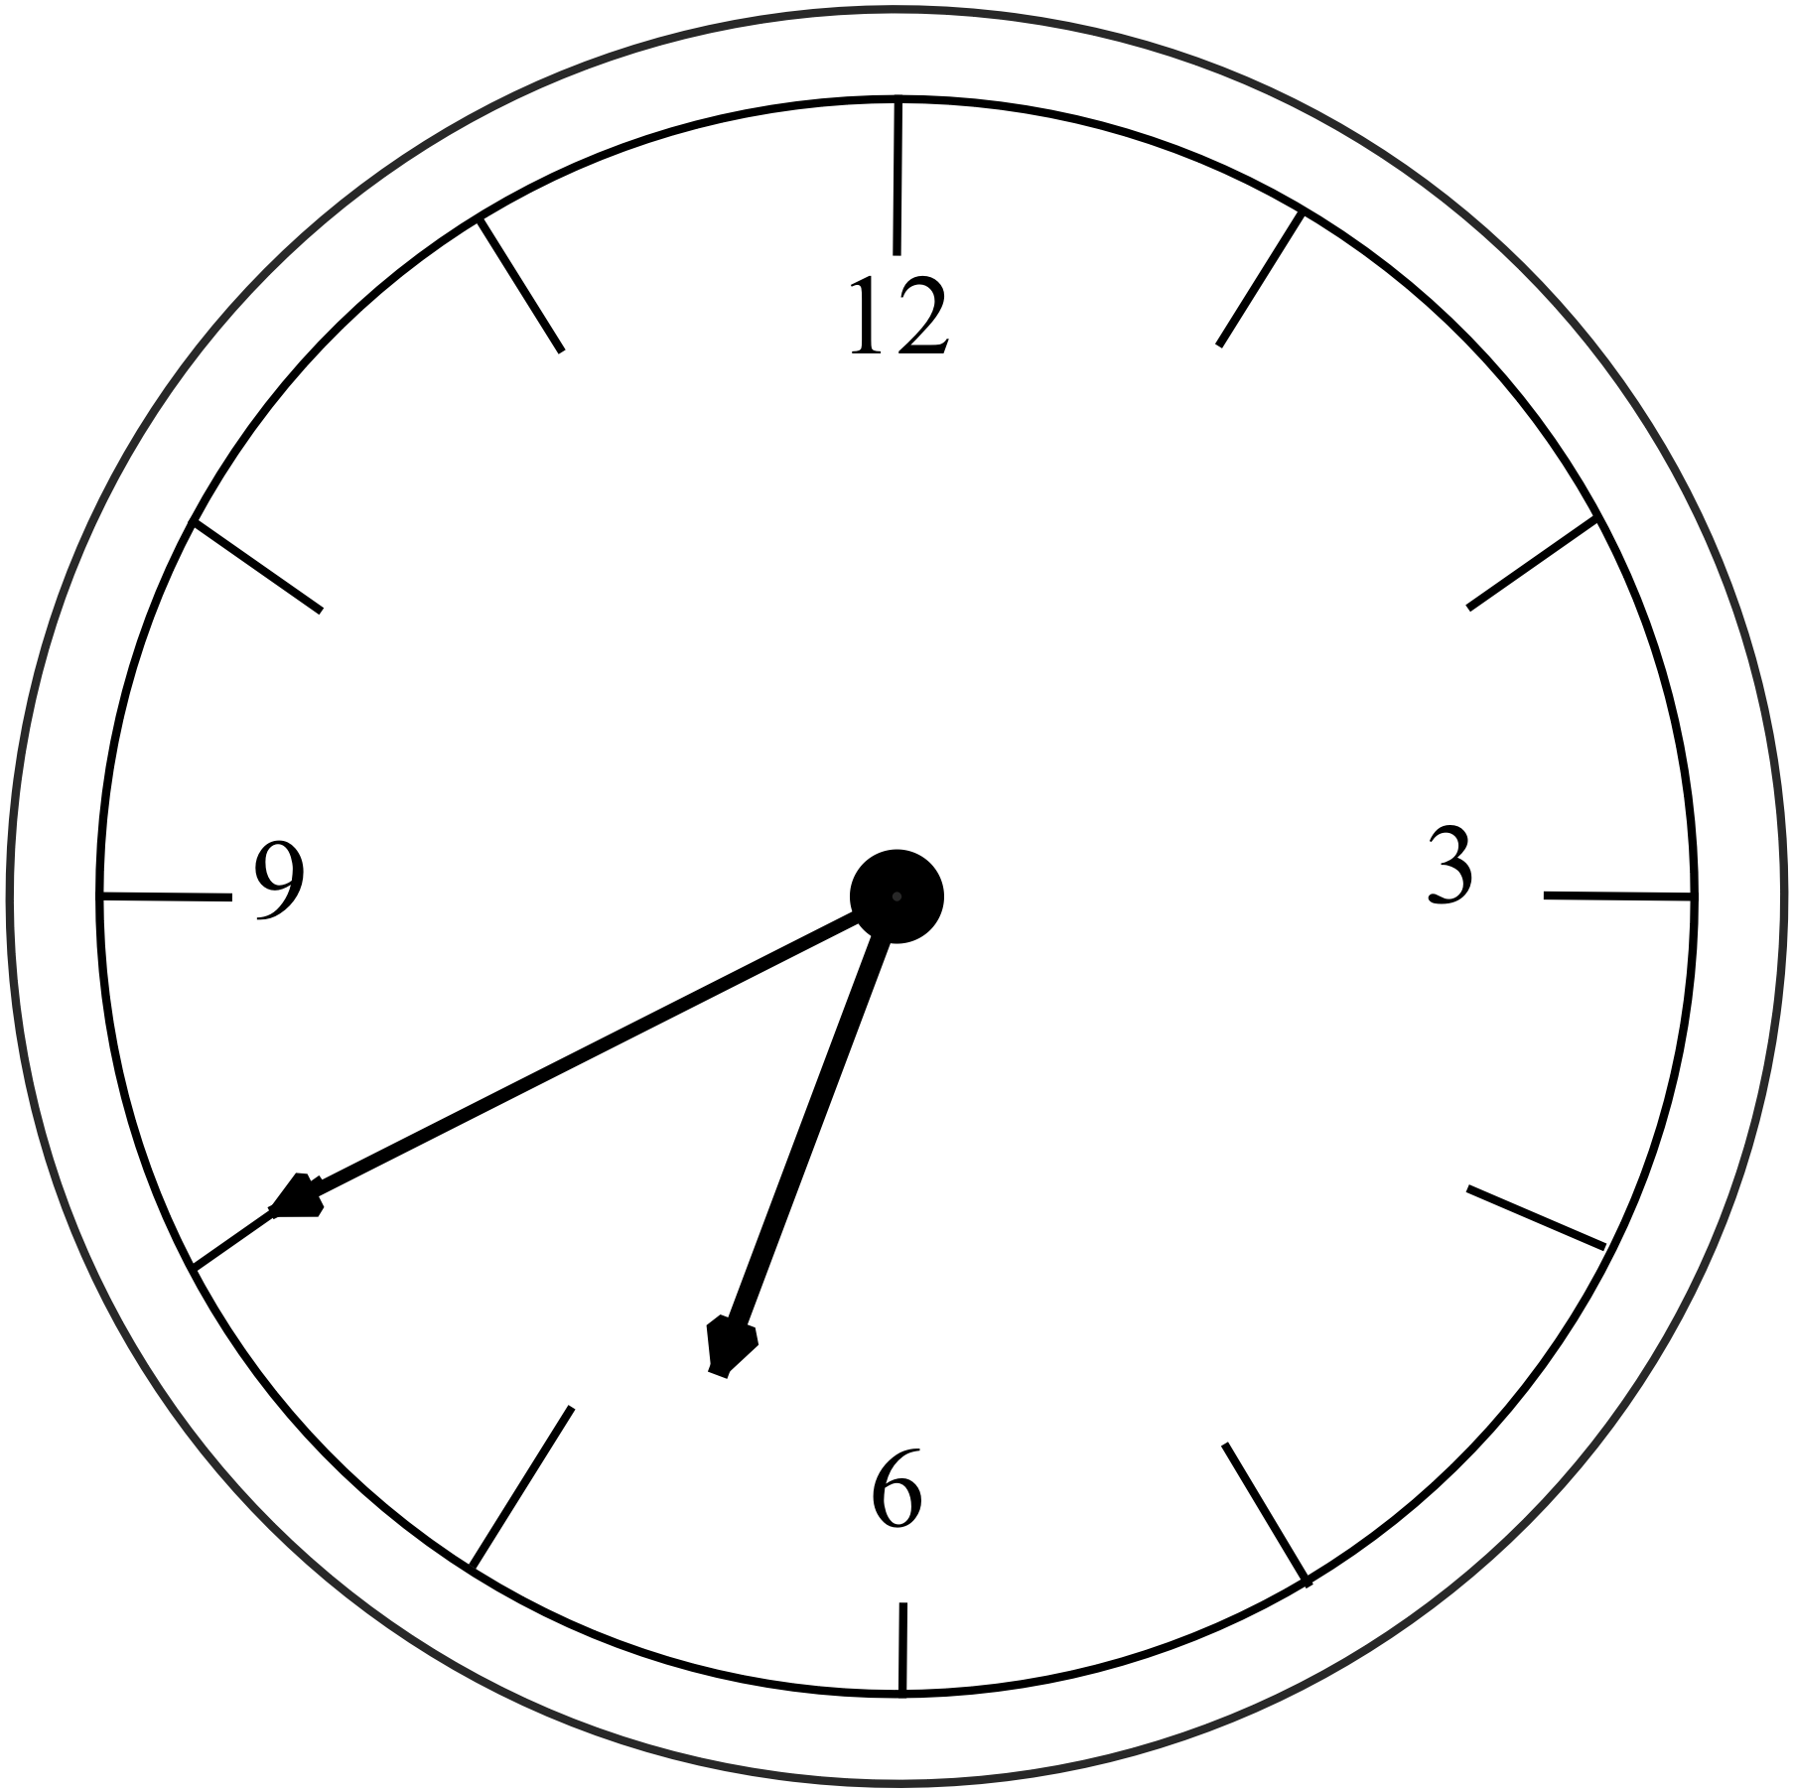

How long was Matthew away from home on this day?

10 hours and 5 minutes 10 hours and 45 minutes
10 hours and 55 minutes 11 hours and 5 minutes
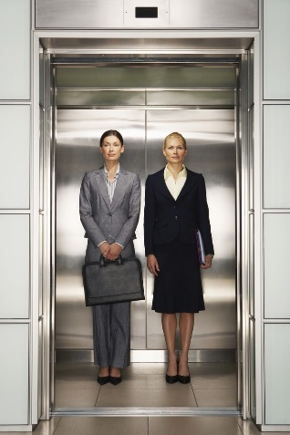
A sign in an elevator gives its maximum load as 1.4 tonnes or 20 passengers.
What would be the average mass of each passenger if the two maximum loads are the same?

70 kg
90 kg
100 kg
140 kg

The mass of a set of 25 pencils is 100 grams.

What would be the mass (in kg) of 1000 of these pencils?

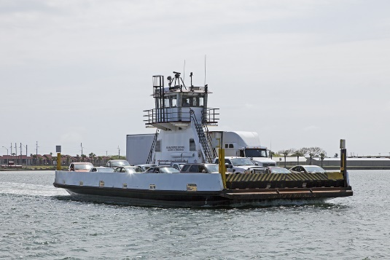
A ferry takes cars across a 750-metre wide river.
The ferry makes the return crossing twice every hour, all day long.
How many kilometres does the ferry travel in a day?
18 km
24 km
36 km
72 km
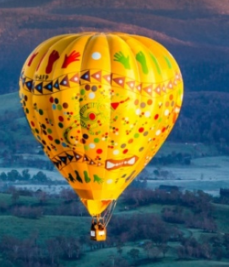
Before take-off, 1500 m³ of outside air is pumped into a hot air balloon using a fan that delivers 2500 litres of air each second.
Given that a cubic metre holds 1000 litres, how many minutes will it take to complete the process?

School Name
Mathematics Test 2017
Year 7 |  | Metric System | Calculator Allowed  Short Answer  Section
 |  |  | Name___________________
Answer all questions in the spaces provided on this test paper by:
Writing the answer in the box provided.
or
Shading in the bubble for the correct answer from the four choices provided.
Show any working out on this test paper. Calculators are allowed.
Which measurement is the same as 3.2 metres?
32 mm 32 cm 320 mm 320 cm
Which unit would be appropriate for measuring the mass of a truck?
grams kilograms tonnes megatonnes

For a recipe, 3.5 litres of milk is needed.
How many times would a 500 ml jug need to be filled to measure the milk?

7 14
70 140
 | How many seconds are there in 4.5 minutes?
An evening radio program gives the time as “a quarter to eight.”
This could be written as:

07:45 08:15 19:45 20:15

Lauren’s two dogs weigh 3.45 kg and 4.25 kg respectively.
What is the difference in their masses?

0.8 grams 8 grams
80 grams 800 grams

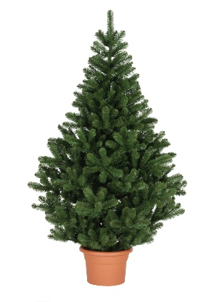
The height of a potted tree was 1.24 metres.
By Christmas it had grown a further 45 cm.
What was the new height of the tree (in cm)?

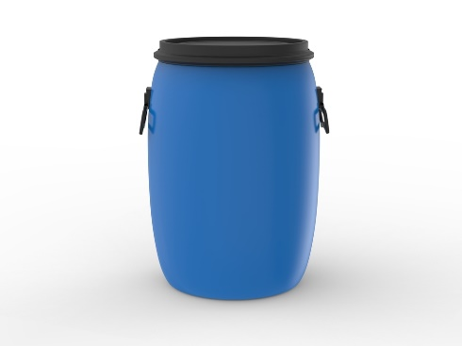
Desta fills a drum with 200 litres of water and empties it into a pool.
She repeats this process 15 times.
How many kilolitres of water has she added to the pool?

Clare places cakes which each have a mass of 600 g onto a wire rack which weighs 4.5 kg.
When she has placed 16 cakes on the rack she lifts it into a display cabinet.
What mass does she lift altogether?

9.6 kg 14.1 kg 16.8 kg 81.6 kg
Oliver exercises by running 800 metres, then walking 500 metres.
He repeats this pattern five times.
How many kilometres does he cover altogether, while exercising?

Joseph finished school at 3.40 pm, then forty minutes later he arrived at his after-school job.
He spent 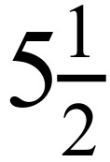 hours at work, before taking 20 minutes to get home.
What time did he get home?
9:10 pm
9:50 pm
10:10 pm
10:50 pm
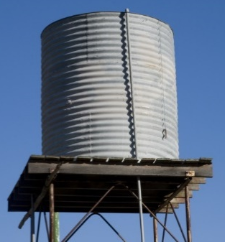
A water tank holds 20 kilolitres when it is full.
A farmer takes 200 litres each day from the tank to fill a stock watering trough.
How many days will the water last, if no water is added to the tank?

Connor signed a contract on the 15th March, which was to take effect 3 weeks later.
On what date did it take effect?

4th April 5th April 6th April 7th April
Questions 14 – 16 refer to the ferry timetable shown below.
Dock | am | am | am | am | am | am | am
City Pier | 6:30 | 6:45 | 7:00 | 7:15 | 7:30 | 8:00 | 8:30
Glenelg Mooring | 6:34 | 6:49 | 7:04 | 7:19 | 7:34 | 8:04 | 8:34
Washington Wharf | 6:39 | 6:54 | 7:09 | 7:24 | 7:39 | 8:09 | 8:39
Quentin Quay | 6:45 | 7:00 | 7:15 | 7:30 | 7:45 | 8:15 | 8:45
Aquarium | 6:49 |  | 7:19 |  | 7:49 | 8:19 | 8:49
Swift Bay | 6:58 |  | 7:28 |  | 7:58 | 8:28 | 8:58
Elizabeth Pier | 7:07 |  | 7:37 |  | 8:07 | 8:37 | 9:07
Rosalyn Cove | 7:12 |  | 7:42 |  | 8:12 | 8:42 | 9:12
Newcombe Cove | 7:18 |  | 7:48 |  | 8:18 | 8:48 | 9:18
Ernest Bay | 7:25 |  | 7:55 |  | 8:25 | 8:55 | 9:25
Kent Quay | 7:29 |  | 7:59 |  | 8:29 | 8:59 | 9:29
Merchants Punt | 7:33 |  | 8:03 |  | 8:33 | 9:03 | 9:33
Waterfront Markets | 7:37 |  | 8:07 |  | 8:37 | 9:07 | 9:37
Hawthorn Dock | 7:41 | 7:48 | 8:11 | 8:18 | 8:41 | 9:11 | 9:41
Glenferrie Crossing | 7:46 |  | 8:16 |  | 8:46 | 9:16 | 9:46
Campbell’s Landing | 7:52 |  | 8:22 |  | 8:52 | 9:22 | 9:52
King’s Inlet | 7:59 |  | 8:29 |  | 8:59 | 9:29 | 9:59
Clarke Anchorage | 8:03 |  | 8:33 |  | 9:03 | 9:33 | 10:03
Warren Haven | 8:07 |  | 8:37 |  | 9:07 | 9:37 | 10:07
George Point | 8:11 |  | 8:41 |  | 9:11 | 9:41 | 10:11
Middle Harbour | 8:15 |  | 8:45 |  | 9:15 | 9:45 | 10:15
Blackfish Head | 8:19 |  | 8:49 |  | 9:19 | 9:49 | 10:19
Stanley Spit | 8:23 |  | 8:53 |  | 9:23 | 9:53 | 10:23
Mason’s Marina | 8:27 | 8:29 | 8:57 | 8:59 | 9:27 | 9:57 | 10:27

 | How long does it take the 6:30 am ferry from City Pier to reach Mason’s Marina?
 | How many minutes less does it take the 6:45 am ferry to complete the same journey?
 | What is the latest time that Thomas could catch a ferry at Swift Bay if he needs to reach Mason’s Marina before 9:00 am?

Brandon ran eight 100 m sprints and nine laps of an 800-metre oval for training.
Daniel ran twenty-eight 200 m sprints and three laps of the same oval.
Which is true?
Brandon ran 7.2 km and Daniel ran 8.0 km.
Brandon ran 8.0 km and Daniel ran 7.2 km.
Brandon ran 8.0 km and Daniel ran 8.0 km.
Brandon ran 8.0 km and Daniel ran 8.4 km.
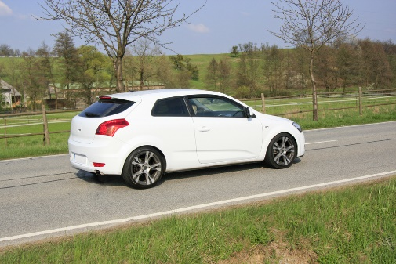
A car driving on the highway uses 12 litres of fuel for every 100 km that it travels.
When driving in the city it uses 16 litres of fuel for every 100 km that it travels.
In one week, the car travels 400 km in the highway and 300 km in the city.
How many litres of fuel does it use?

School Name
Mathematics Test 2017
Year 7 | Metric System | Non Calculator Section
ANSWERS

Question | Working and Answer
400 g is reasonable. The first two choices are two small and the last too heavy.
3rd Answer
 | 2nd Answer
 | Length is 13.5 cm or 135 mm (check printed test page and allow 1 mm tolerance)
 | 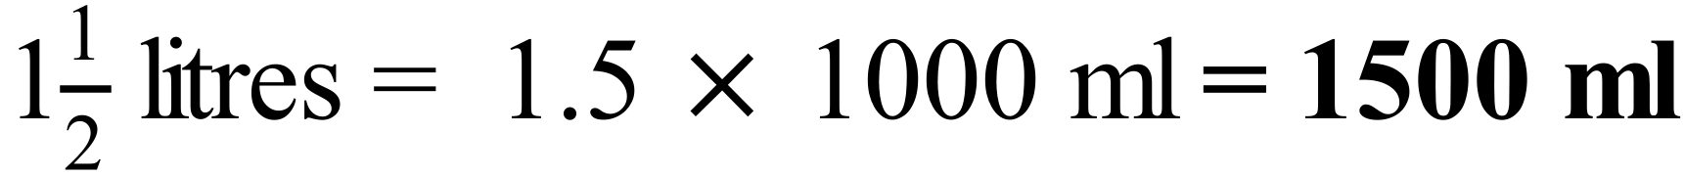
 | 3rd Answer
 | From 1:55 pm to 2:00 pm is 5 minutes and from 2:00 to 3:27 is an hour and 27 minutes or 87 minutes.
Megalitres ( a million litres ) would be best for dam of this size.
3rd Answer
Each division = 20 ÷ 4 5 km/h
Speed shown = 60 + 5 + 3(estimated) = 68 km/h
2nd Answer
 | 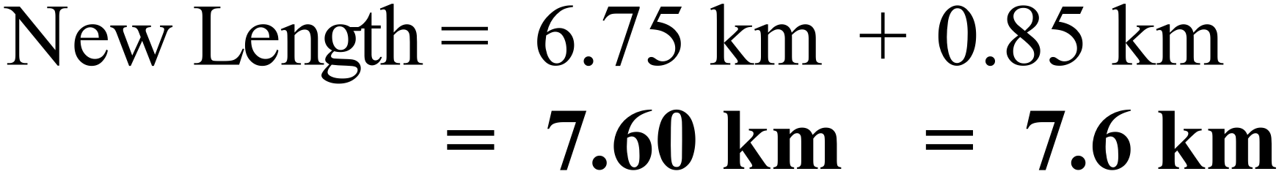
5:30 from Victoria Cross. Arrives at Rouse Hill at 6:09
5:30 to 6:00 is 30 minutes
Time = 30 min + 9 min = 39 minutes
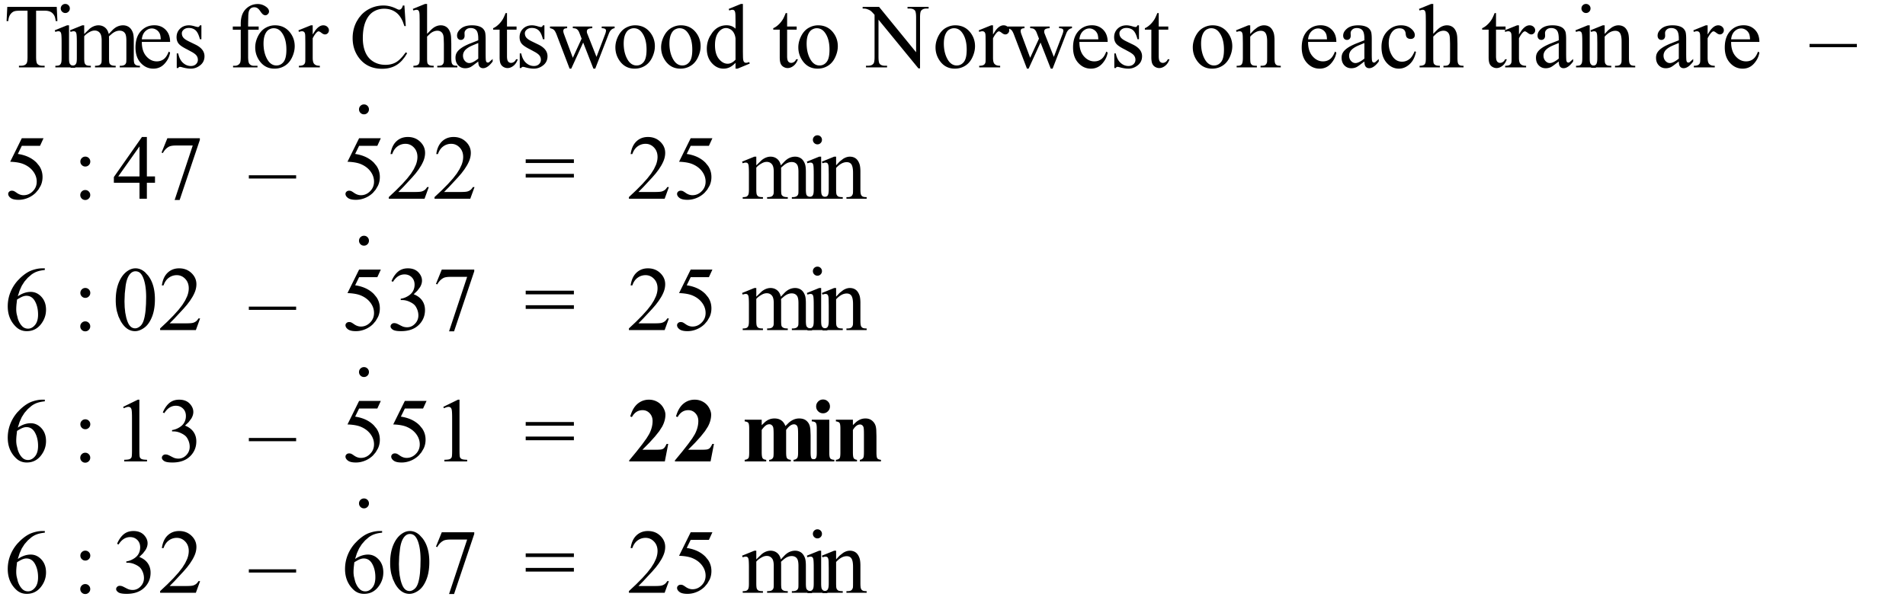
2nd Answer
 | 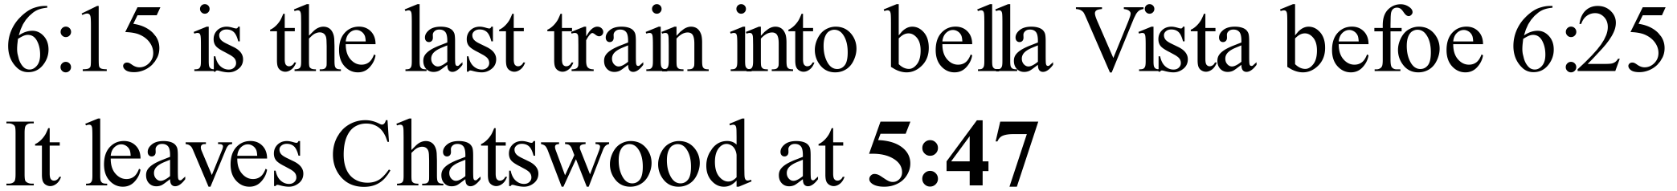
Time on clock is 6:40
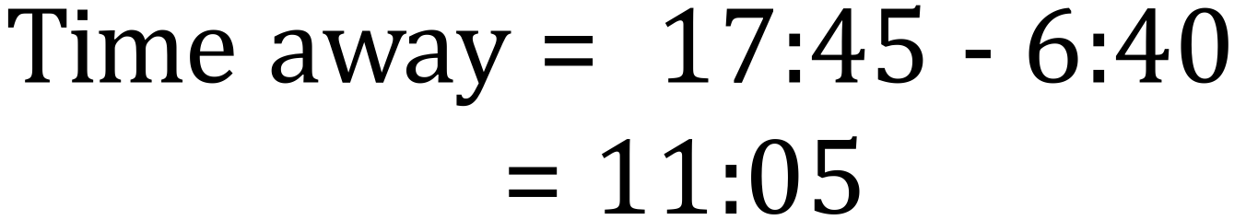
4th Answer
1.4 tonnes = 1400 kg
1st Answer
 | 
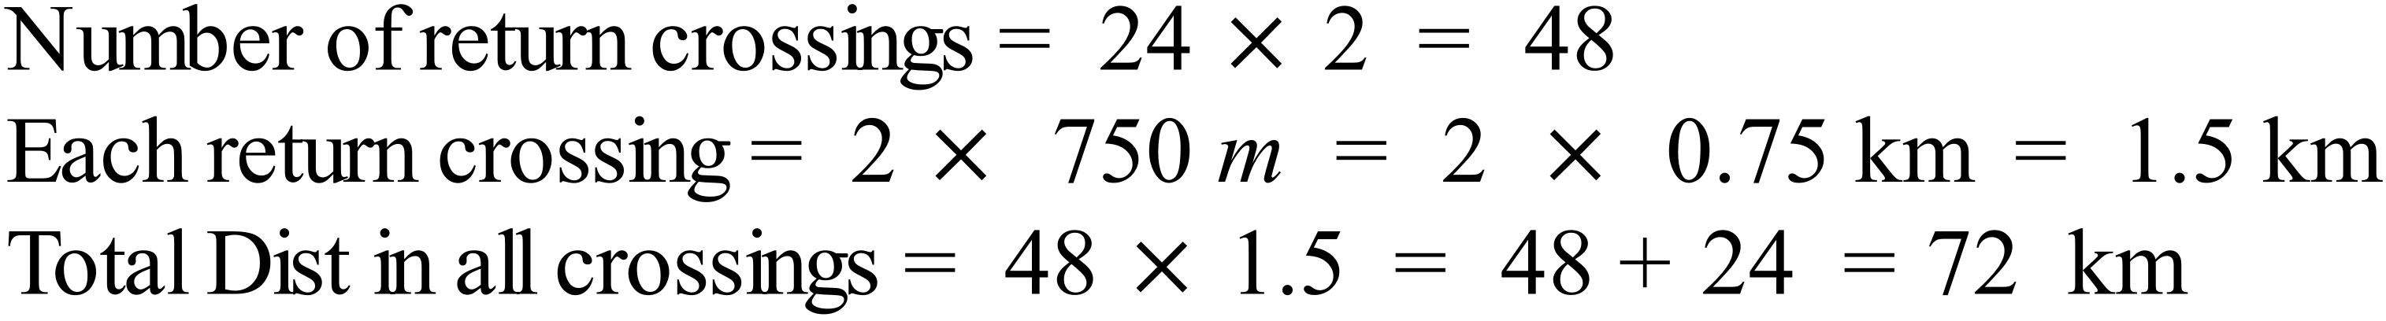
4th Answer
 | 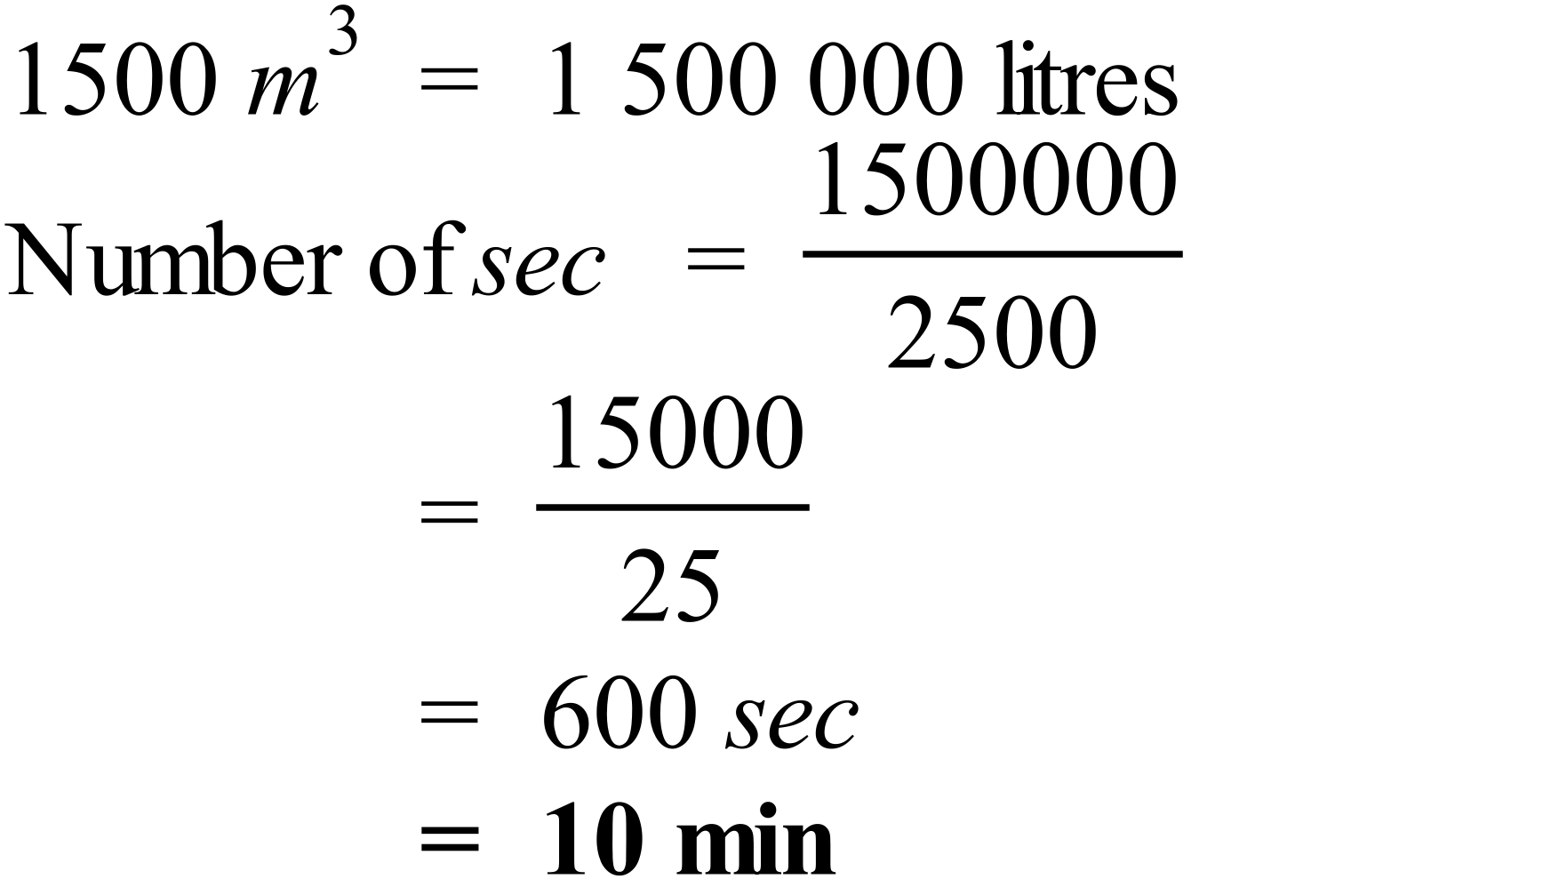

School Name
Mathematics Test 2017
Year 7 | Metric System | Calculator Allowed  Short Answer  Section

ANSWERS
Question | Working and Answer
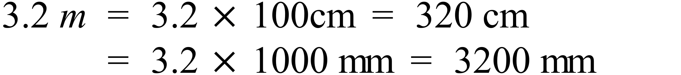
4th Answer
Tonnes would be appropriate, but the first two would not as they are smaller units, and mega tonnes are millions of tonnes, so would be too big a unit.
3rd Answer
  - L = 3500 ml.
1st Answer
 | 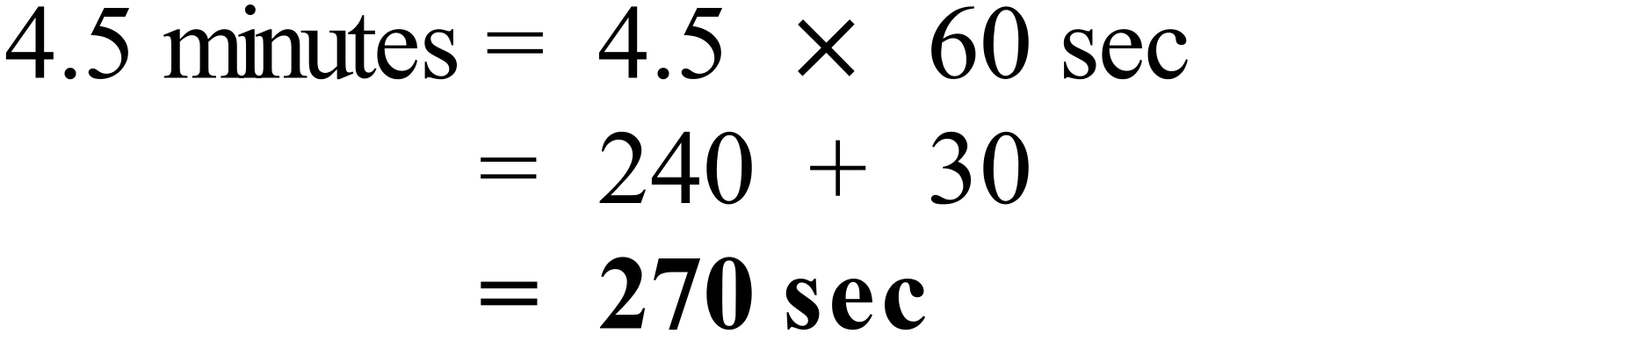
A quarter to eight = 7:45
In the evening this is written as 7:45 +12:00
Time is 19:45
3rd Answer

4th Answer
 | 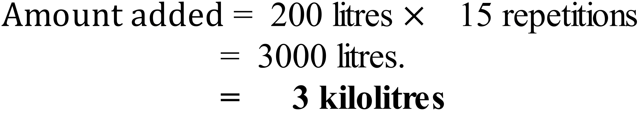
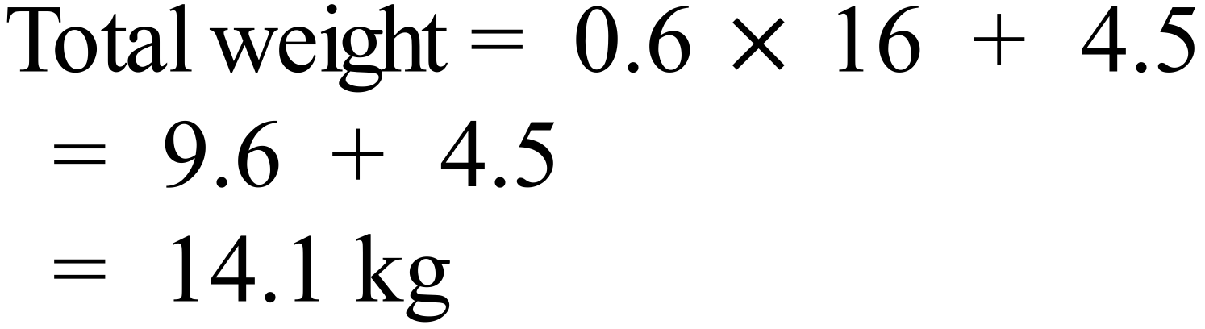
2nd answer
 | 

3rd Answer
 | 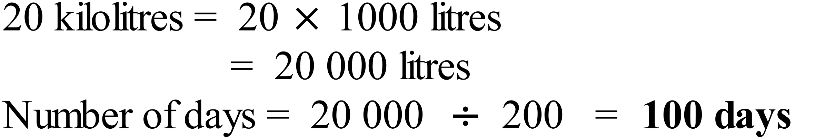
One week after the 15th March is 22nd March.
Two weeks after the 15th March is 29th March.
Two weeks and 2 days after the 15th March is 31st March.
Three weeks after the 15th March is 5th April.
2nd Answer
6:30 to 8:30 is 2 hours, so 6:30 to 8:27 is 2 hours less 3 minutes.
i.e. 1 hour and 57 minutes
6:45 to 8:30 is 1 hour and 45 min,
so 6:45 to 8:29 is 1 hour and 45 min less 1 minute.
i.e. 1 hour and 44 minutes
Difference = 1:57 – 1:44 = 13 minutes less
Ferries arriving at Masons Marina before 9:00 are at 8:57 and 8:59
Only the 8:57 arrival stops at Swift Bay.
It leaves there at 7:28 am
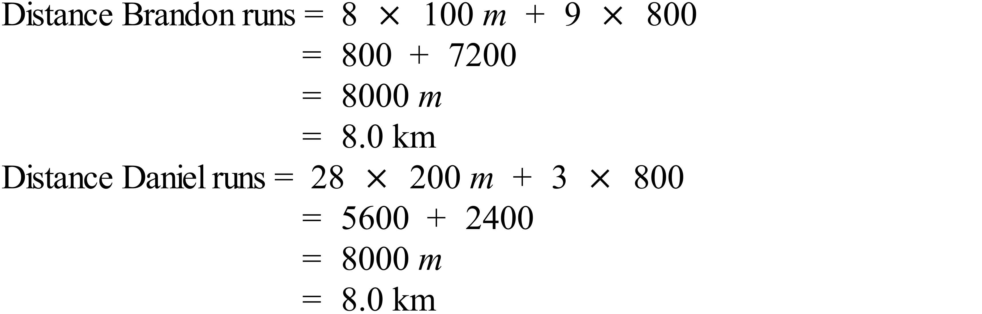
3rd Answer
 | 